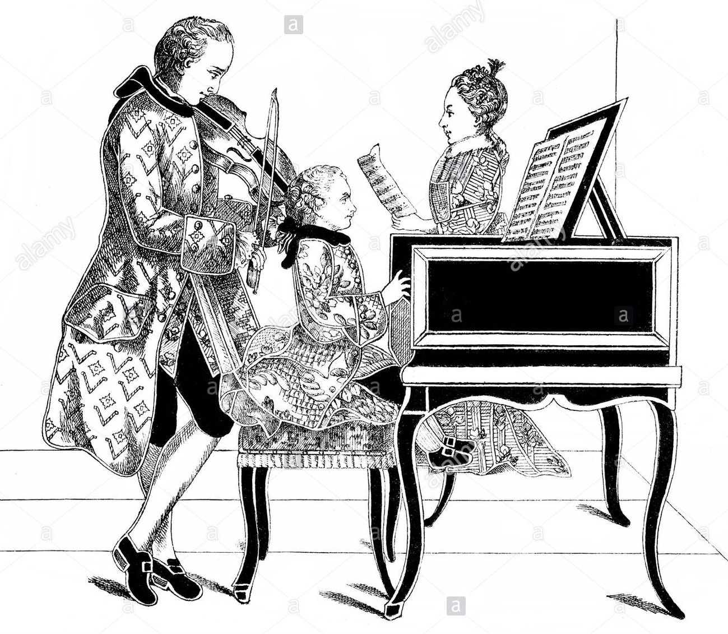

Music an Appreciation
  - Asst.prof. YUTAKORN SARIKKAGANON

Course Syllabus MUS1205

Contents

Part I Elements
1. Sound: (Pitch, Dynamics, Tone Color)
2. Performing Media: (Voices, Instruments)
3. Rhythm
4. Music Notation
5. Melody
6. Harmony
7. Key
8. Musical Texture
9. Musical Form
10.Performance
11. Musical Style
Part II The Middle Ages
- Music in the Middle ages (450-1450)
- Gregorian Chant
- Secular Music in the Middle ages
- The Development of Polyphony: (Organum)
- Fourteenth-Century Music: (New Art in France)
Part III The Renaissance
- Music in the Renaissance (1450-1600)
- Sacred Music in the Renaissance
- Secular Music in the Renaissance
Part IV The Baroque
- Baroque Music (1600-1750)
- Music in Baroque Society
- The Concerto Grosso
- The Fugue
- The Opera
- Henry Purcell
- Antonio Vivaldi
- Johann Sebastian Bach
- George Frideric Handel & Oratorio
Part V The Classical
- Classical Music (1750-1820)
- Sonata
- Variations
- Minuet
- Rondo
- Joseph Haydn
- Wolfgang Amadeus Mozart
- Ludwig Van Beethoven
Part VI The Romantic
- Romanticism in Music (1820-1900)
- The Art Song
- Franz Schubert
- Robert Schumann
- Frederic Chopin
- Franz Liszt
- Peter Ilyich Tchaikovsky
- Antonin Dvorak
- Johannes Brahms
10.Giacomo Puccini
11.Richard Wagner
12.Gustav Mahler
Part VII The Twentieth Century
- Musical Styles (1900-1950)
- Impressionism and Symbolism
- Claude Debussy
- Igor Stravinsky
- The Expressionism
- Bela Bartok
- Musical Styles Since 1950
Part VIII Blues-Jazz
- Jazz Styles (1900-1950)
- Ragtime
- The Bluse
- New Orleans Style
- Swing
- Bebop
- Jazz Styles Since 1950
Part IX Pop
- Standard Pop 1960
- Singers
- Bands
- Songs
Part X Rock
- Development of Rock
- Singers
- Bands
- Song
- Rock Music in American-English Society

Part XI Nonwestern Music
- Music in Nonwestern Cultures
- Music in Africa
- Music in India
- Music in China
- Music in Thailand
- Gamelan
- World Music in Brief

