Theory 2
Chord
What Exactly Is a Chord?
A chord is simply a set of notes or pitches that are played simultaneously. Chords are mostly built using superimposed thirds. A chord is essentially two or more different intervals, the interval of a third most commonly. If you do not feel confident with intervals do make sure to read the blog post on intervals before embarking on this post about chords.
The chord type that we most commonly see and use is the triad. Triads are simply three note chords. ‘Tri’ comes from the greek language and simply means three, think about a triangle!
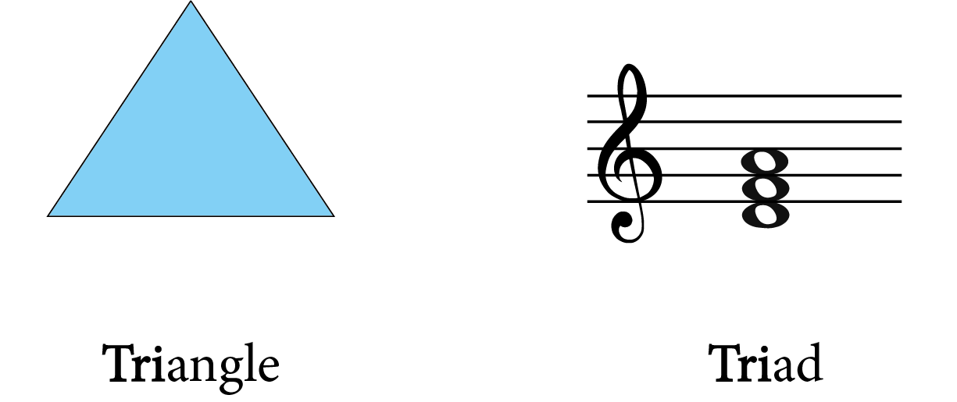

A chord doesn’t just have to consist of three notes, it can also consist of four or more notes. The most common types of chord that have more than three notes are seventh chords or extended chords, but more on this later. Let’s look at triads first.
What Are Triads?
As stated earlier, a triad is a chord consisting of three notes. It is built using the root, a third above the root and then a fifth above the root. See below an example of the C major triad. The notes in this triad are C, E, G.

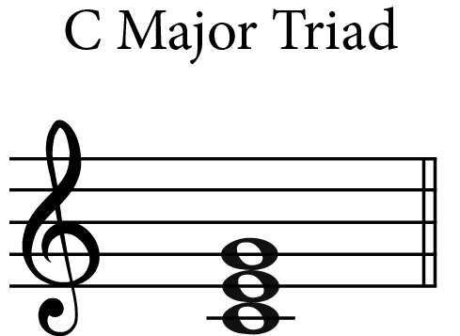

A triad is a type of tertian chord. A tertian chord is where we stack multiple thirds on top of each other.In order to confidently build chords, you need to be really certain of your scales. Knowing and understanding your scales helps you to know what notes to include in your chords. To refresh your memory on this topic make sure to check out the scales blog here.
It is also useful to really understand what intervals are and how to work them out as chords are built up using different intervals. Having a clear idea of not only how to work out the intervals number but also its descriptive word is vital when learning about chords. When reading on you will see why. Let’s write out the scale in the key of C major. There are seven notes/degrees in total in the C major scale and we can easily write a triad on every single one of these scale degrees. By the time we have finished there will be seven different chords.
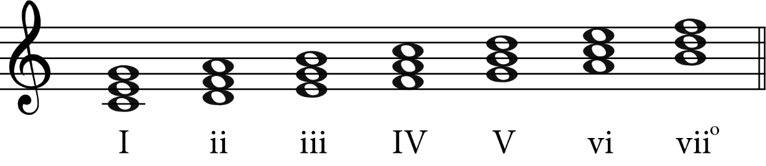
As you can see, each chord includes the root, a third above the root and a fifth above the root! Remember, the root is simply the bottom note of each triad/chord.Make sure you notice that each of these chords is either written on all lines or all spaces.
- Chord I includes the notes c, e, g
- Chord II includes the notes d, f, a
- Chord III includes the notes e, g, b
- Chord IV includes the notes f, a, c
- Chord V includes the notes g, b, d
- Chord VI includes the notes a, c, e
- Chord VII includes the notes b, d, f
There are four main triads that you will come across and these are:
- Major Triad – A Major third and a Perfect fifth above the root
- Minor Triad – A Minor third and a Perfect fifth above the root
- Diminished Triad – A Minor third and a Diminished fifth above the root
- Augmented Triad – A Major third and an Augmented fifth above the root

Major Triads
A major triad is built using a major third and a perfect fifth above the root. Let’s look at the major chords in the key of C major.
- Chord I – This includes the notes C, E and G
- Chord IV – This includes the notes F, A and C
- Chord V – This includes the notes G, B and D

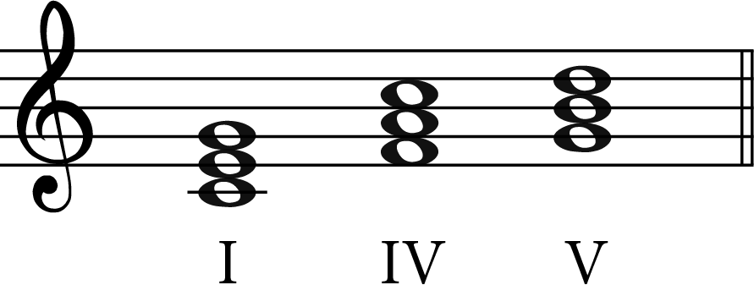
In a major scale, chords I, IV and V will always be major triads. Whether this be in the C major scale, F major scale or any major scale for that matter. Minor triads are built using a minor third and a perfect fifth above the root.
Minor Triad
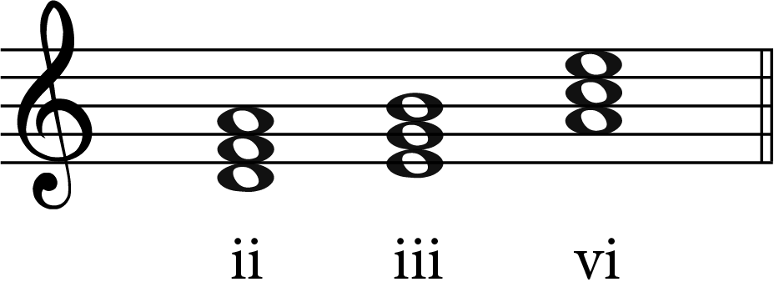
In a major scale, chord ii, iii and vi are always minor chords/triads. Whether this be C minor, A minor or any minor scale for that matter.
Diminished Triads
Diminished chords/triads are made up of a minor third and a diminished fifth above the root. Let’s look at the diminished chord in the key of C major
- Chord viio – This includes the notes B, D, F

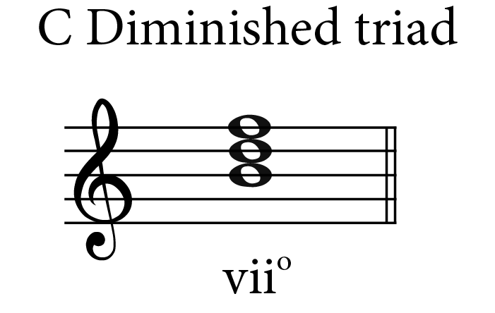
In a major scale and a minor scale, chord vii is always a diminished chord.
Augmented Triads
Augmented chords/triads are made up of a major third and an augmented fifth above the root. In a minor scale chord III+ is always an augmented chord. There are no augmented chords in a major scale.Let’s have a look at the augmented chord in the key of C majors relative minor – A minor.
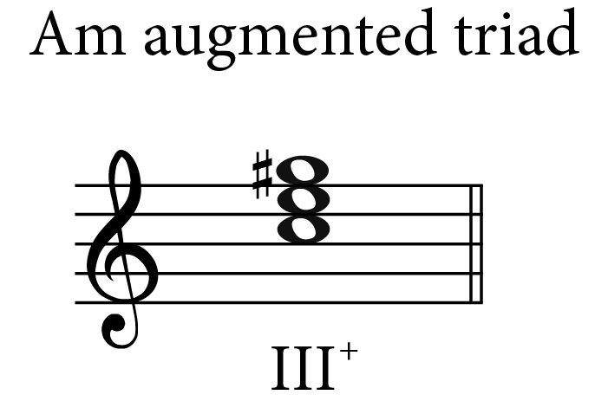

Chord III+ in A minor includes the notes C, E and G#. Notice how we have a G# in this chord, this is because G# is A minor’s raised seventh note. We most commonly use the harmonic minor scale when writing chords. By raising this note we end up with an augmented 5th between the notes C and G#.
Common Seventh Chords
Seventh chords are triads with an additional note, this additional note is a seventh above the root. There are six common types of chords in this section:
- Dominant seventh chord
- Minor seventh chord
- Major seventh chord
- Diminished seventh chord
- Half diminished chord
- Augmented seventh chord
There are more of these types of chords in your music but this is a great place to start.
Dominant Seventh Chord
Dominant seventh chords are built using a major triad on the fifth note of the scale and then a flat seventh, also known as the dominant seventh, added on top. For example in the key of G major, the Dominant seventh chord would start on the note D, the fifth note of the scale. (The fifth note of any scale is called the dominant note) G A B C D
We would then have a major triad starting on D. The notes in a D major triad are – D F# A. We then simply add a flattened seventh on the top of this major triad. In this case it would be a C natural. As you can see C is the seventh scale degree of D major but normally in D major we would have a C#. Having a C natural is flattened down by a semitone from the original note C sharp.
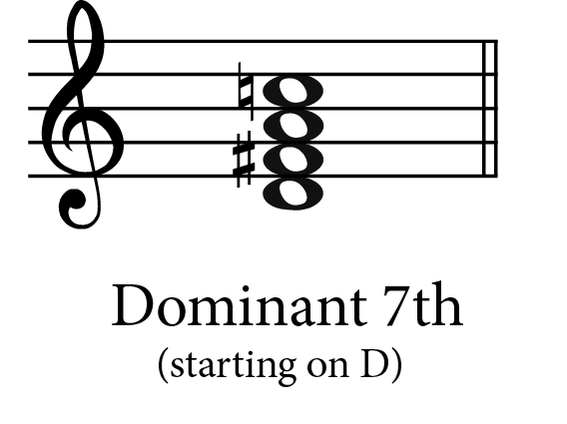
Minor Seventh Chord
A minor seventh chord is built using a minor triad with a minor seventh added to the top. Let’s take a look at an example in C minor. The tonic triad of C minor is C, Eb, G now we simply add a minor seventh to the top of this chord. The minor seventh from C natural is Bb. (If these intervals are confusing, have a look at our intervals article). So, the chord will be as follows: C, Eb, G, Bb
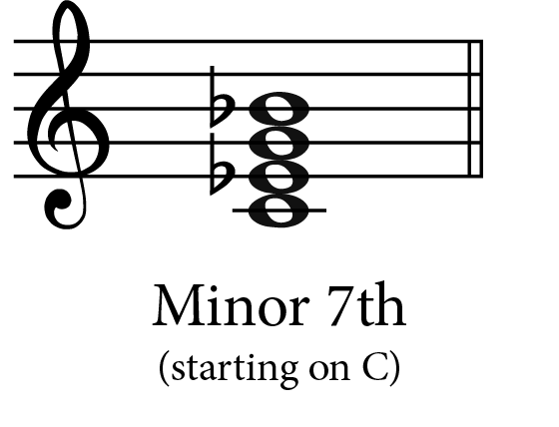

Major Seventh Chord
A major seventh triad consists of a major triad with an additional major seventh added to the top. For example, let’s take the G major tonic triad. This has the notes G, B, D. We now simply add a major seventh to the top of this triad. This would be an F sharp as a major seventh above G natural is an F sharp. G major seventh will have the notes G, B, D, F sharp
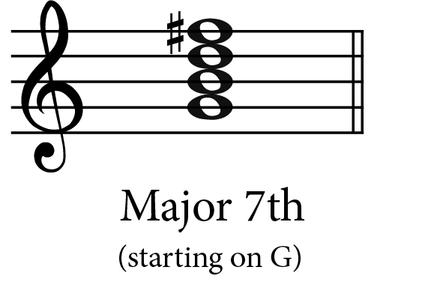
Diminished Seventh Chord
Diminished seventh chords consist of a diminished triad with a diminished seventh added to the top. Let’s write out a diminished chord starting on B. A diminished chord starting on B includes the notes B, D, F – remember in a diminished chord we must make sure that the interval of a fifth is diminished. We can now add in a diminished seventh to the top of this chord. A diminished seventh above B natural is A flat. So B diminished includes the notes B, D, F, Ab.
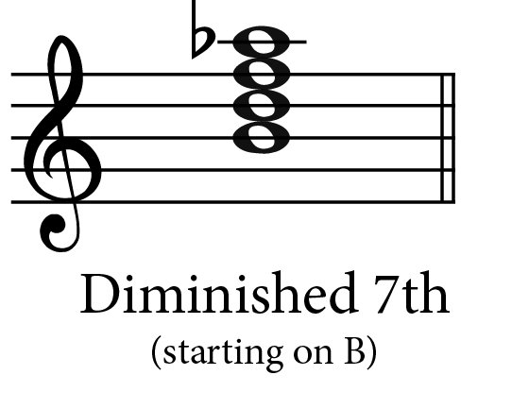

Half Diminished Chord
Half diminished chords have a diminished triad with an additional minor seventh. Where a diminished chord had both intervals diminished this one is half diminished because only one of the intervals is diminished. Let’s look at an example in C minor. C minor diminished triad has the notes C, Eb, Gb. Now we simply add in the minor seventh to the top. A minor seventh from C natural is Bb. So C minor half diminished chord has the notes C, Eb, Gb, Bb.
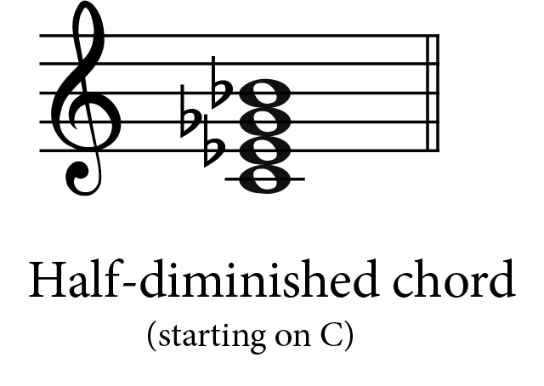
Augmented Seventh Chord
Augmented seventh chords are built using an augmented triad with an added minor seventh. Let’s look at an example in C major. C major augmented triad will include the notes C, E, G#. Remember for it to be an augmented triad the interval of a fifth must be an augmented fifth. Now we simply need to add a minor seventh on the top. The minor seventh above this would be a B flat. A C major augmented seventh will be C, E, G#, Bb
